Rules in the Henry Lunt Household
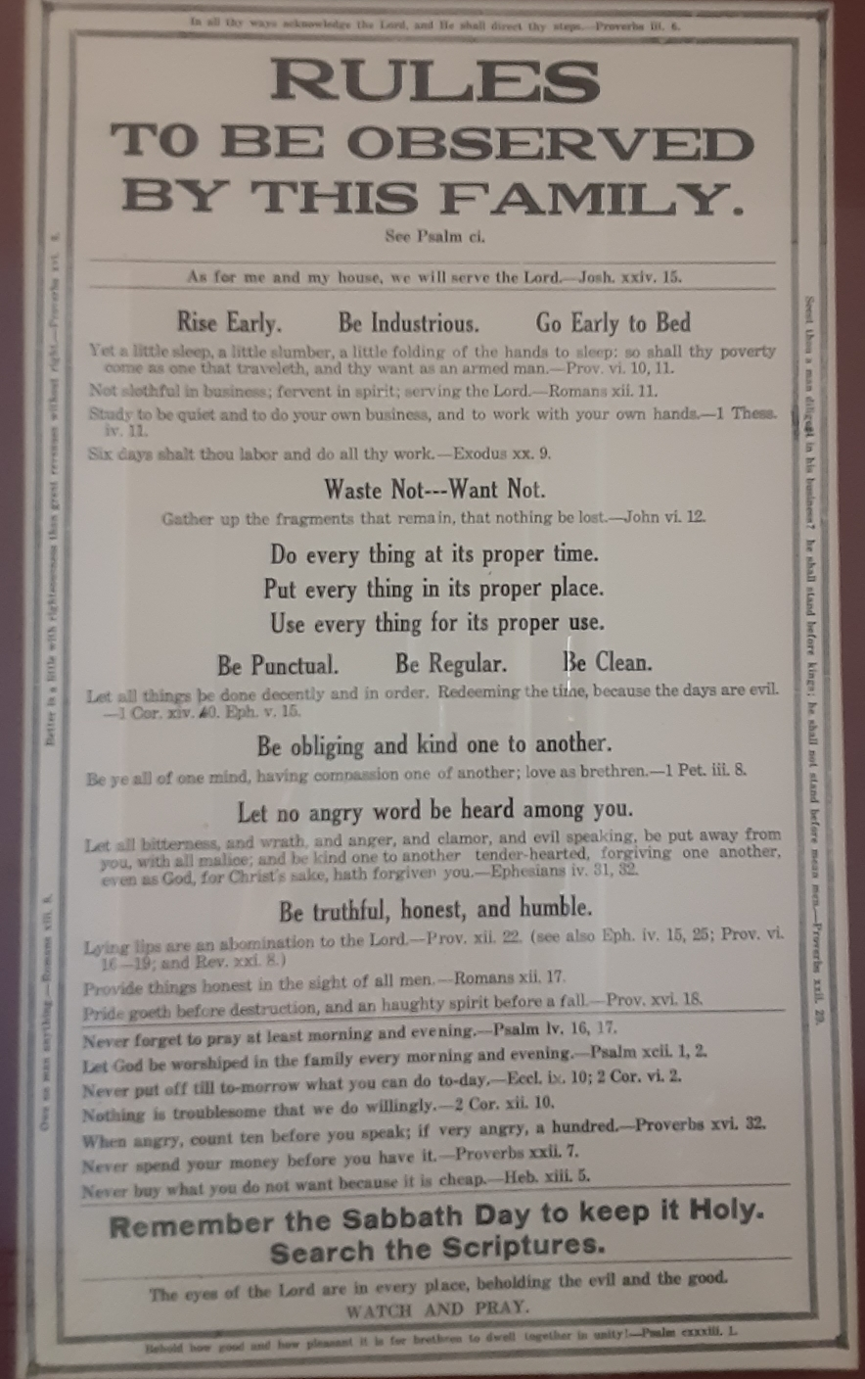
This plaque always hung in the Cedar City, Utah home of Henry Lunt and his second wife, Mary Ann Wilson. When their daughter Martha Henrrieta married Lehi Willard Jones, a copy of the plaque was given to them, and hung in their new home at 128 south 100 west in Cedar City. Their youngest son, William Lunt married Claire Bennion, and they moved into that home and lived there for the remainder of their married lives. During a period of remodeling the plaque was discovered hanging between two walls where it has been hidden for many years. (From FamilySearch.org)

